Assignment 6

Ishaq Khan

INFS 6353

12/4/2023

1. Collect some text data based on one or more keyword(s) of your choice. Then perform the following on the data:

Keyword: Science

The keyword that was selected was the term “Science”.

1. This is the word cloud of the term Science from the Wikipedia Link.

A lot of the word on here relate to science terms used often. You’ll find words like “solutions, methods, data, analysis, etc.” which all represent common terms used in the Science realm. The more frequent words in the middle that are larger are not very important words like “and, the, as, etc.” This is because it’s a Wikipedia page and it has many sentences to describe and talk about the topic science.

1. This is the Sentiment Analysis

We find that the graph indicated a lot of positive sentiment. The top four emotions are “positive, joy, anticipation, and trust.” This could also be die to the recent scientific boom occurring in research, education, and information.

1. This is the Top 10 most Populous Countries in the World on a Bar Graph from the Wikipedia link: <https://en.wikipedia.org/wiki/World_population>

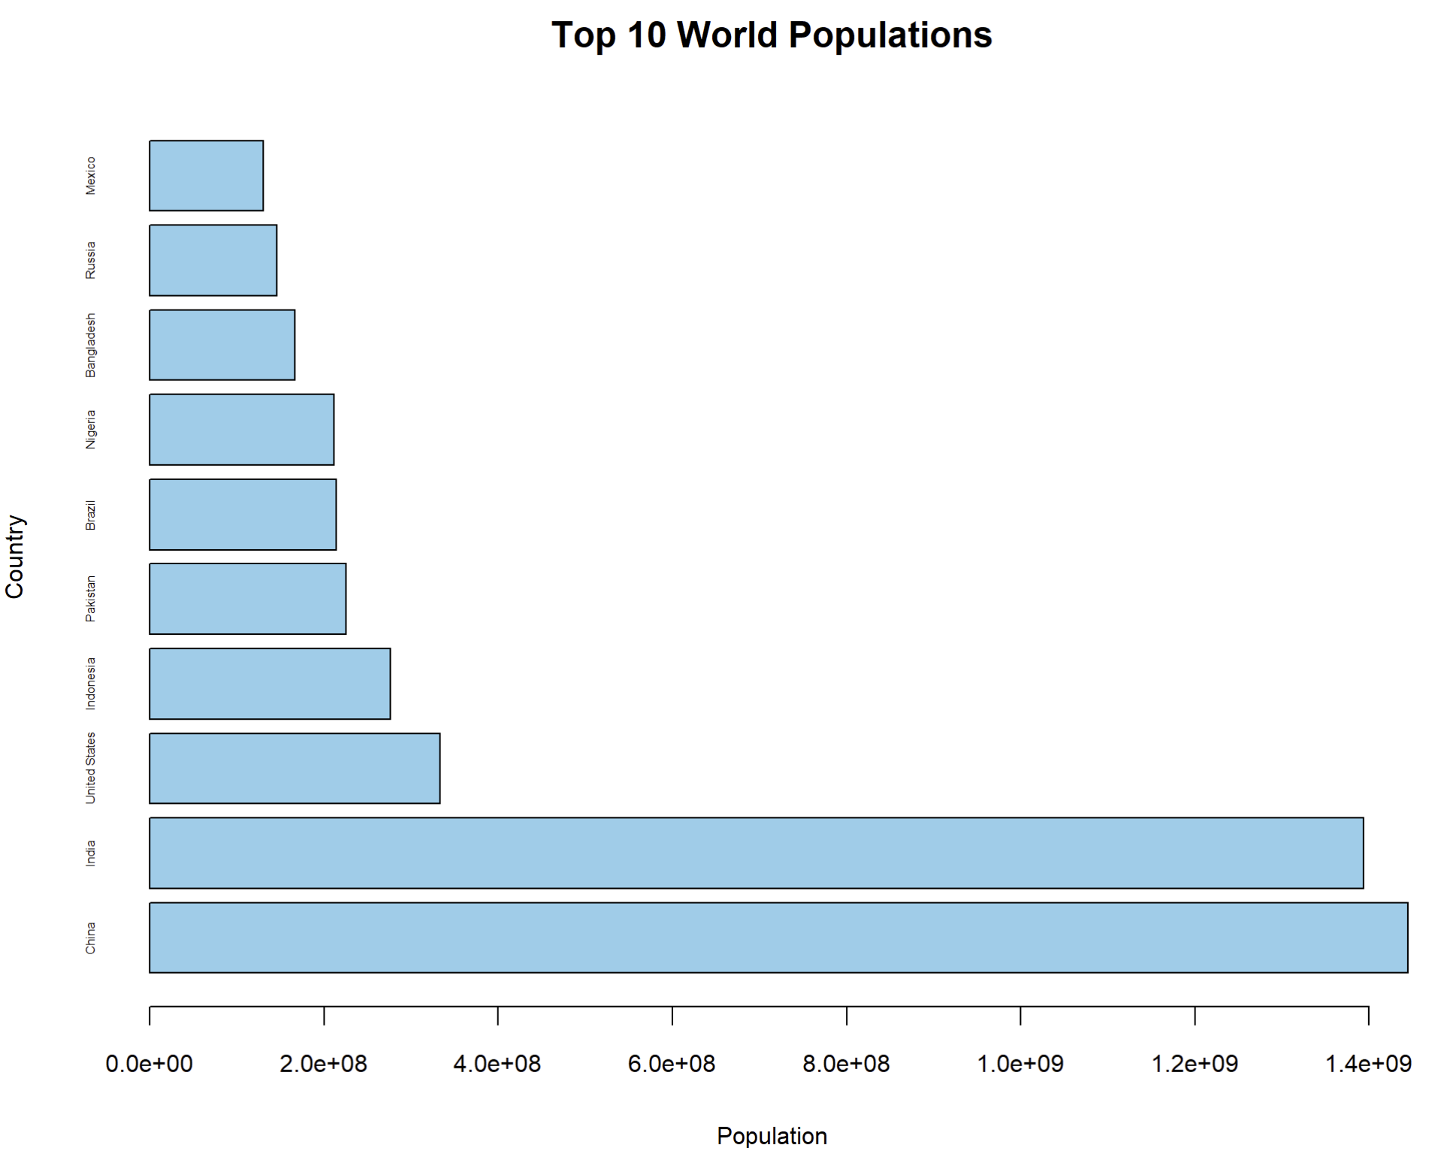

This bar graph shows the result of the top 10 most populous countries in the world. The numerical value on the x-axis couldn’t really be adjusted since the difference between the top 2 and the rest were so large that the having its actual value wouldn’t make sense.

1. This is the Top 10 most Populous Countries in the World on a Pie Chart from the Wikipedia link: <https://en.wikipedia.org/wiki/World_population>

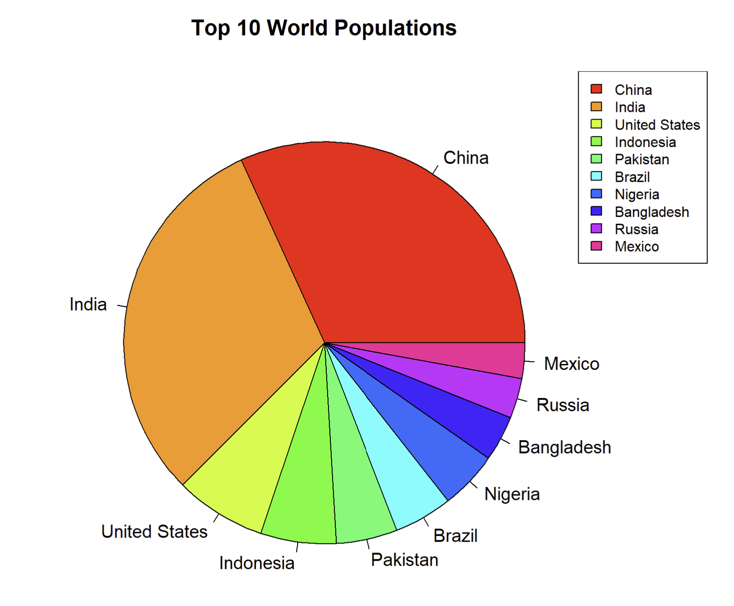

This pie chart shows the information better than the bar chart. It doesn’t show the actual numerical value of the population but rather visualizes it better by comparing it to each other as one whole pie dividing it among each other based off the values that are their population count.